Department of Computing

School of Electrical Engineering and Computer Science

CS-250: Data Structure and Algorithms
Class: BSAI 2A

Lab 2: Pointers in C++

Date: 16th September 2026
Time: 10:00 am – 12:50 pm

Lab Instructor: Urooj Akmal

Lab 2: Pointers in C++

Introduction
This lab is about the pointers. In C++, a pointer refers to a variable that holds the address of another variable. Like regular variables, pointers have a data type. For example, a pointer of type integer can hold the address of a variable of type integer. A pointer of character type can hold the address of a variable of character type.
Objectives
This lab will revise the old concepts taught to the students in the previous semesters.
Tools/Software Requirement
- Visual Studio C++ (or any standard C++ IDE such as Code::Blocks, CLion, or g++ compiler).
Description
Pointers are used to point towards a particular memory address. In this lab we will use the pointers and perform task with the help of them.

Lab Tasks
Task 1
Write code to find the memory in bytes occupied by int, long, double, float and char.
Output:
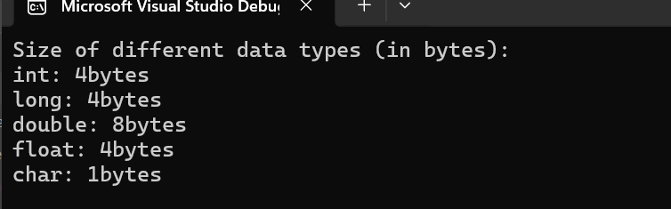

Code:
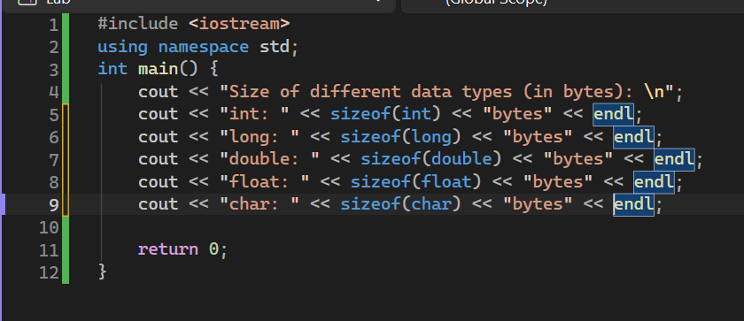
Task 2
Consider the following program and answer the questions.
void main()
{
int a, *pa; // Statement 1
pa = &a; // Statement 2
cout<<"pa = &a --> pa = "<<pa<<endl<<endl;
pa = pa + 1; // Statement 3
cout<<"pa = pa + 1 --> pa = "<<pa<<endl<<endl;
pa = pa + 3; // Statement 4
cout<<"pa = pa + 3 --> pa = "<<pa<<endl<<endl;
pa = pa - 1; // Statement 5
cout<<"pa = pa - 1 --> pa = "<<pa<<endl<<endl;
}
Output:
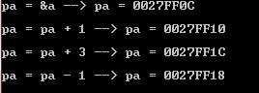
- Why does the memory address stored in pointer “pa” vary by 4?
Answer: It changes by 4 bytes cause an int occupies 4 bytes so pointer arithmetic changes according to the data type that’s why its changed by 4 bytes.
- Will the address still vary by 4 if the data type of the above mentioned code changed from “int” to “long”? Explain your answer.
Answer: As the ‘long’ data type also occupies 4 bytes, the address will still vary by 4.
- If we try to multiply the address pointed to by “pa” what will happen? Is this logically or programmatically correct? Attach screen shot of the output you get when you try this multiplication.
Answer: Multiplying a pointer is not allowed so it will cause a compiler error. It is not programmatically correct.
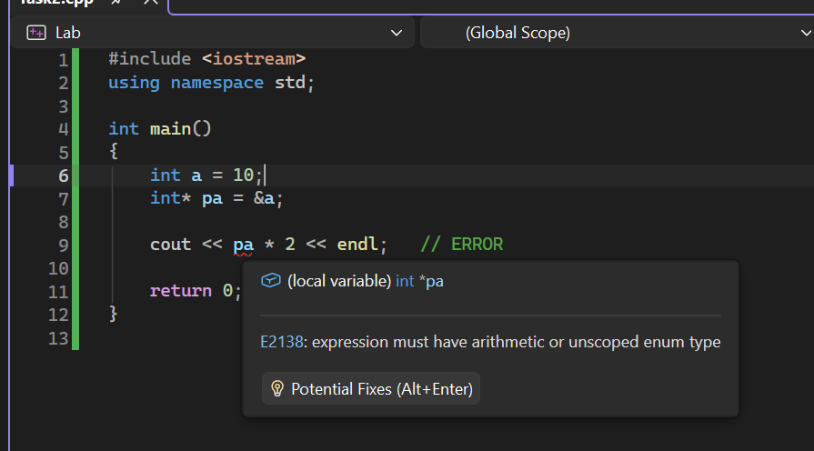
Here we can see that the program does not run.
Task 3

int list[5]={3,6,9,12,15};
int *pArr= list;

Your task is to write a piece of code that prints all values stored in the array list using only pointer variable pArr. Do not use the conventional way of printing values by numbering indexes.

Code:
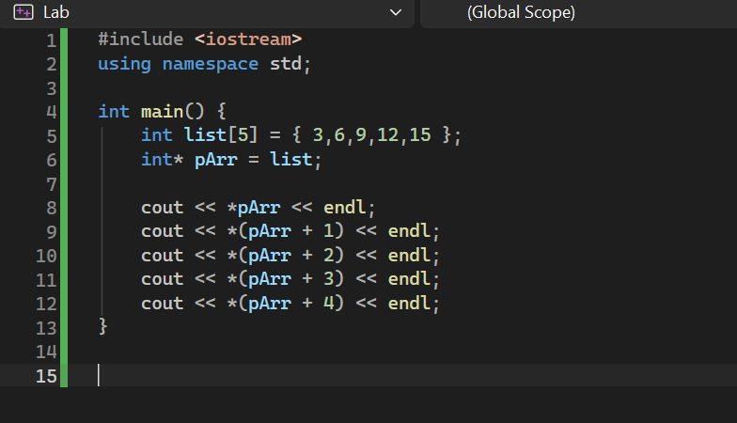
Output:
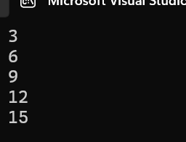

Task 4
Write output of the following C++ codes in your document without executing it.
Example code a)
int x[4] = {0,4,6,9};
int *p, a=3;
p=x;
(*p)++;
cout<<*p<<endl;
cout<<*(p+1)<<endl;
p++;
*p=*p+a;
cout<<*p<<endl;
p=p+2; //What is happening here?
cout<<*p<<endl;

Output:
1
4
7
9
- p = x makes the pointer point towards x[0]. So, when (*p)++ happens, the array becomes {1,4,6,9} and the pointer is pointing to 1 right now. So, 1 is printed. *(p+1) means print next element of array which is 4 so 4 is printed. p++ moves the pointer to x[1] which is 4. *p = *p + a means 4 + 3 as a=3 and pointer is pointing to 4 so the array becomes {1,7,6,9} hence 7 is printed. p = p+2 moves pointer two iterations so now it points to 9 aka x[3] hence 9 is printed.

Example code b)
int a, *p, *q;
int arr[4]= {0};

p=arr;
q=p;

*p=4;

for(int i=0; i<3; i++){
a=*p;
p++;
*p=(a+i);
}
for (int j=0; j<4; j++){
cout<<*q<<" ";
q++;
}

Output:
4 4 5 7
- p and q both initially point to the first element of arr. *p = 4 makes the first value 4, then the loop moves p forward and calculates the next values. The array becomes [4, 4, 5, 7], and q is used to print all four values

Task 5
int a=5, b=10;
int *pa=&a; //pa and pb are pointer variables of type int.
int *pb=&b;

int **ppa=&pa; //ppa and ppb are called double pointers or pointers-to-pointers.
int **ppb=&pb;
- Write code of a function that swaps values of variables a and b. Input to the function should be the address of both the variables.
Output:
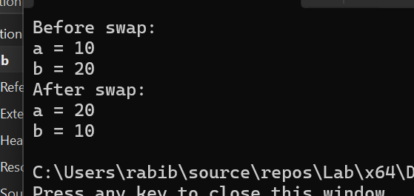
Code:
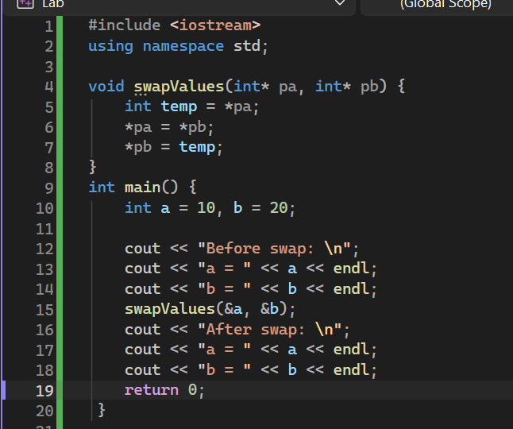
- Write code of a function that swaps values of the variables a and b using pointer-to-pointer variables ppa and ppb.
Code:
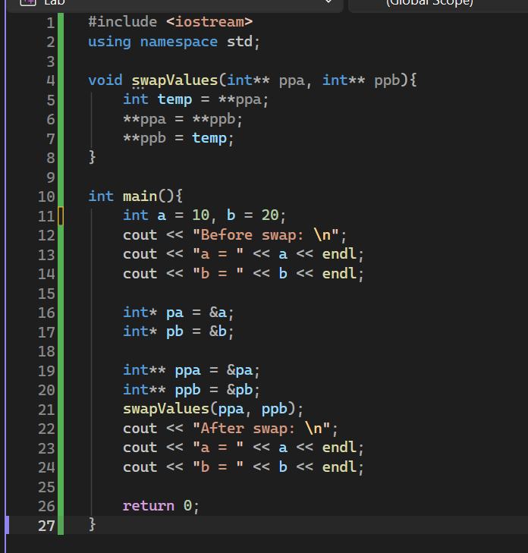
Output:
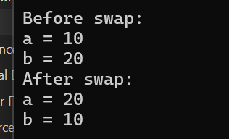

Task 6

- A teacher records marks for a group whose number of students and number of subjects are entered at runtime. Each row represents a student and each column a subject.
- Read and validate rows and cols before allocation. Allocate an int** marks array of row pointers, then allocate cols integers for each row.
- Read marks from 0 to 100 and display the matrix. Assume entered marks are valid. Use *(*(marks + r) + c) in at least one complete input or output loop.
- Calculate each student’s total. Display the student with the highest total and that total. If totals tie, report the first student. Use student numbers starting at 1.
- Delete all rows, then delete the row-pointer array and set marks to nullptr. Explain what would remain allocated if only delete[] marks; were executed.
- For two students and three subjects, sketch the pointer variable, the array of two row pointers and the two separately allocated rows. Label marks, marks[0] and marks[0][0].
Hint: determine the first student’s total before comparing other students. Keep separate variables for the best total and its student number.
Input by row | Expected result
2 × 3: 50 60 70 / 80 40 90 | Totals: 180, 210; top student: 2
2 × 2: 40 60 / 50 50 | Totals: 100, 100; top student: 1
1 × 1: 75 | Total: 75; top student: 1

Output:
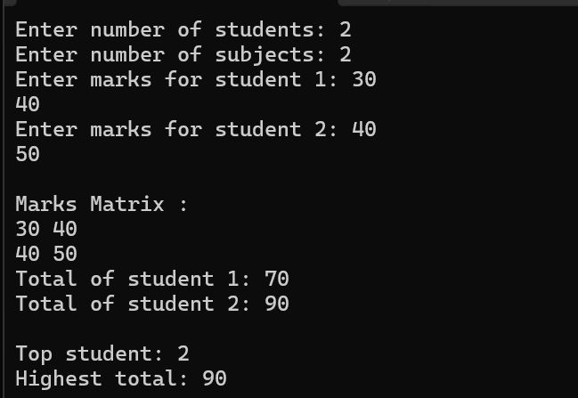
Code:
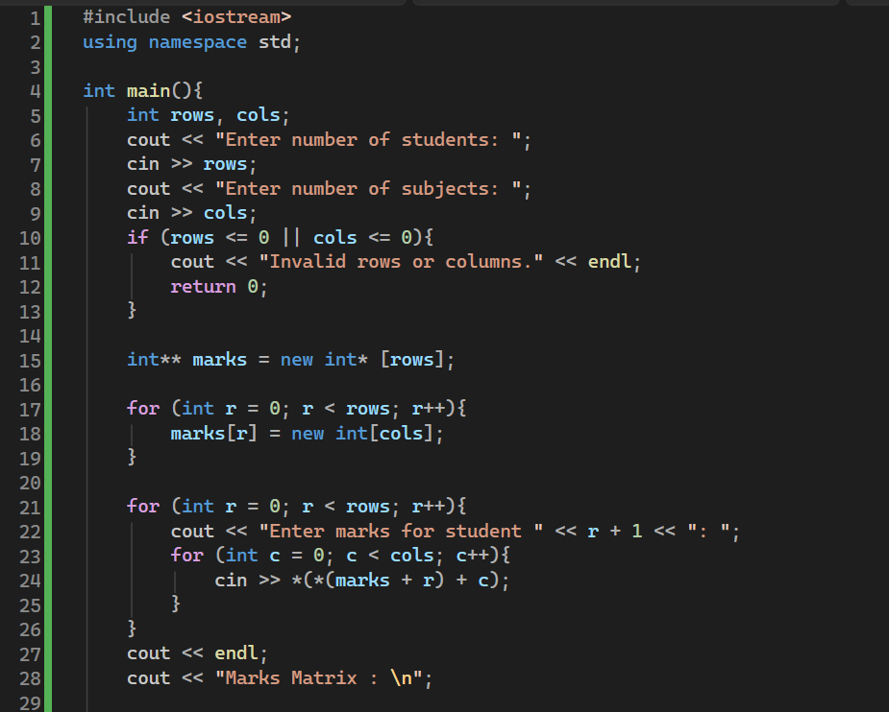
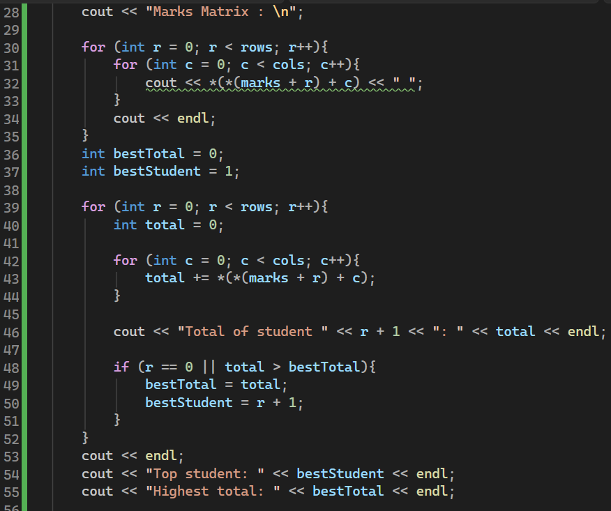
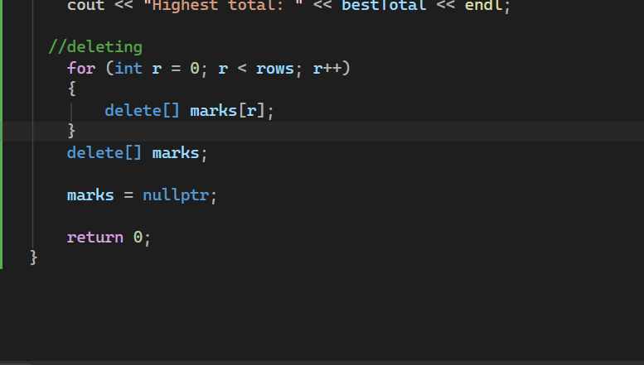

Task 7
A new student joins after the marks have been entered. Write a separate program that reads n (1–10), allocates n marks and then stores one additional mark.
1. Allocate a second block of n + 1 integers. Copy the original n values into it using pointer notation. Read the new mark into the final position.
2. Release the old block. Make the original pointer refer to the new block, update the stored size, and display all values.
3. Release the final block exactly once. Explain why changing n alone does not increase the old block’s capacity.
Check: n = 3; marks 45 60 75; new mark 90 → 45 60 75 90. Also test n = 1; mark 0; new mark 100 → 0 100.
Hint: allocate → copy → append → delete old block → update pointer and size. Other pointers to the old block then become dangling.
Output:
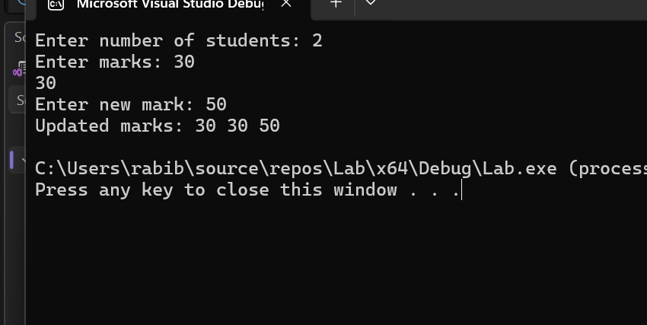
Code:
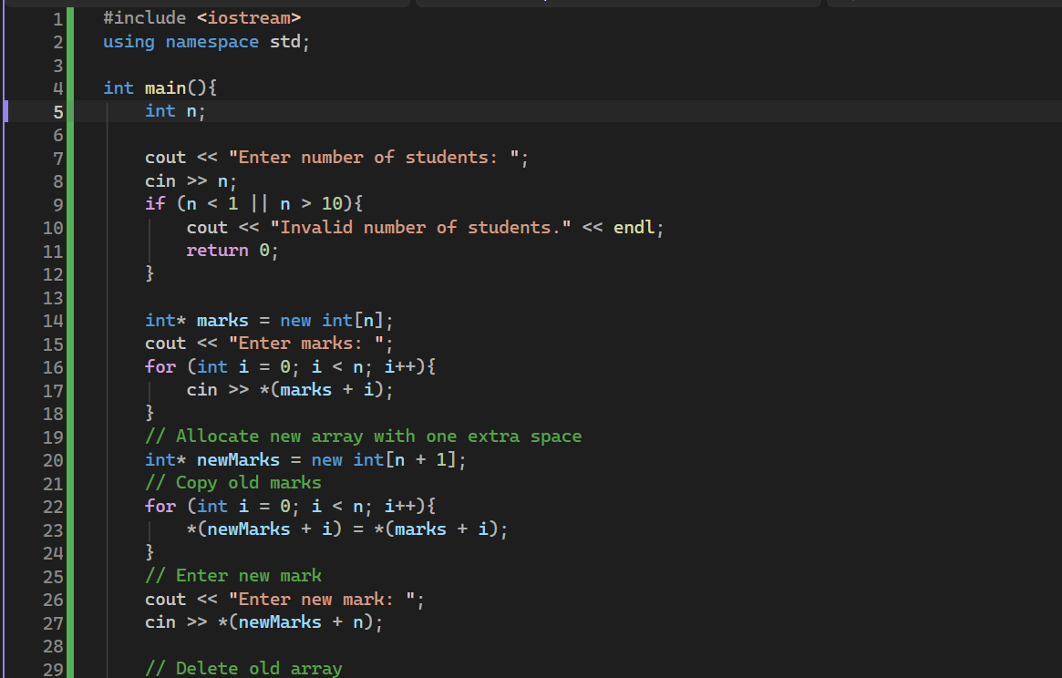

Task 8

The following fragment is intended to read and display three integers. Inspect it before running it; its current behaviour is undefined.
int n = 3;
int* values = new int[n];
for (int i = 0; i <= n; i++)
cin >> values[i];
delete values;
cout << values[0];
- Identify three errors. For each, state the problem and explain its consequence.

- First problem is that should be i < n rather than i <= 3 as values[3] is out of bounds for array
- Second problem is that should be delete[] values rather than delete values, wrong syntax, compile error.
- Trying to access a dangling pointer which is undefined behavior.

- Write a corrected complete program that reads and displays all three integers, releases the allocation correctly and resets the pointer. Test with 4 5 6.
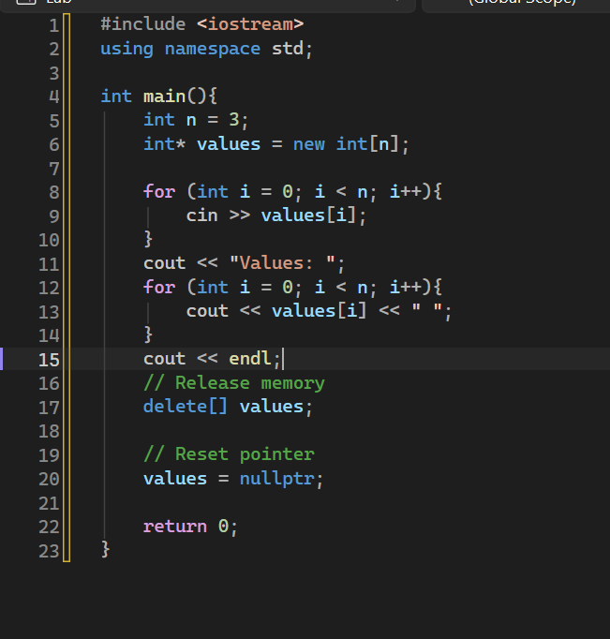
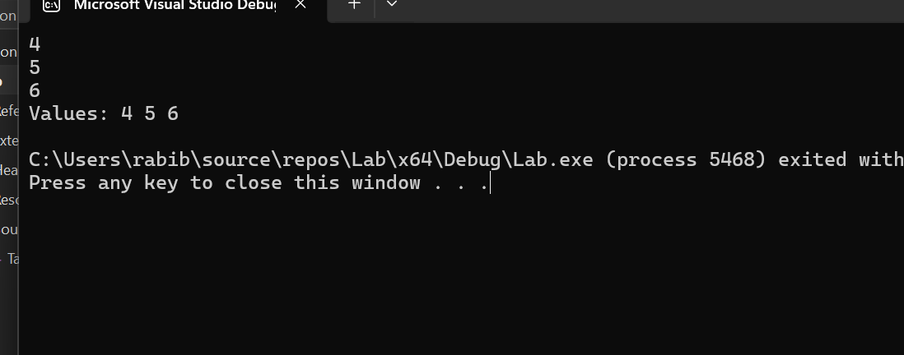
Briefly distinguish an out-of-bounds access, a dangling pointer and a memory leak. Explain why a program appearing to run successfully does not prove its memory accesses are valid.

- Out-of-bounds access: Accessing memory outside the allocated array, e.g. using values[3] when the array has size 3.
- Dangling pointer: A pointer that still points to memory after that memory has been deleted.
- Memory leak: Allocated memory that is never released, causing wasted memory.
A program may appear to run successfully even with invalid memory access because the error may not immediately crash the program. The result is still undefined behaviour, so the program cannot be considered correct or safe.

Deliverables
Compile a single word document by filling in the solution part and submit this Word file on LMS. The name of word document should follow this format. i.e. YourFullName(reg)_Lab#. You must show the implementation of the tasks in a complete Word document to get your work graded. You must also submit this Word document on the LMS.
Note: Students are required to upload the lab on LMS before deadline.
Use proper indentation and comments. Lack of comments and indentation will result in deduction of marks.

Lab Rubrics
Assessment | Doesn’t meet Expectation  (1-2) | Meets Expectation  (3-4) | Exceeds Expectation  (5) | Marks
Software Problem Realization  (CLO2 – PLO2) | The Student is unable to understand and outline the problem and doesn’t use the relevant method to solve it. | The student requires some guidance to completely comprehend the problem and to differentiate the data structure and algorithm comprehensively. | The student fully understands the given problem, is able to analyze the relevant method to solve it, and develops a detailed program flow.
Software Tool Usage  (CLO3 – PLO5) | The student has no idea on how to use the basic tools of the software. The codes have syntax errors, and parts of the codes are missing. Also, they are unable to imitate the required output | The student has a limited command on the basic tools of the software and operated it under supervision. The codes are correct in terms of their syntax, however, the program output is not always correct. | The student has full command on various tools available in the software. Furthermore, his/her coding is complete and functional, and the program output is correct. Moreover, they can easily manipulate the code to design a particular solution
Ethics and Adherence to Laboratory Safety Rules  (CLO4 - PLO 8) | The student does not behave according to the professional ethics by following ethical norms applicable to the software industry such as acknowledgement while using publicly available data/ code. Disturbs the lab environment, doesn’t take care of safety measures, and/or isn’t punctual. | The student partially demonstrate their commitment to professional ethics by following ethical norms applicable to the software industry such as referencing and acknowledgement while using publicly available data/ code. Exhibits better behavior, works by taking into account the safety measures, and is punctual. | The student clearly express the commitment to professional ethics by following ethical norms applicable to the software industry such as referencing and acknowledgement while using publicly available data/ code. Encourages others to maintain lab decorum, and alerts them to follow safety measures.

